Decision support for forest management

Lecture 4 outline, Introduction to NetWeaver

# Introduction

1. First developed in the late 1980s by Dr. Michael Saunders and Bruce Miller at Penn State University
2. The story of NetWeaver
3. An object-oriented, graphic rule-base system
   1. A formal representation of logic-based reasoning
   2. The model constitutes a formal logical discourse
4. Fuzzy logic
5. Recall the elements of a knowledge-based system
   1. A language system (semantics and syntax)
   2. A presentation system (the interface)
   3. A knowledge system (a knowledge base)
   4. A problem-processing system (an engine)
   5. This lecture primarily focuses on a, b, and c
6. And recall, the language system is said to be “ontologically committed” to the engine
   1. In the case of NetWeaver, the language system is primarily graphic

# Why logic?

1. Well suited to modeling large, complex, abstract problems.
   1. If I can reason about it, I can model it.
2. Especially, high dimensional, abstract problems related to ecosystem management
   1. Ecosystem sustainability
   2. Ecosystem resilience
3. There are some challenges
   1. A lot of new concepts and details
4. But after reasonable mastery, it’s also fun and powerful
5. It’s also highly transparent
   1. Good for sharing knowledge among disciplines - collaboration
   2. Good for communicating to non-technical audiences
      1. Models are reasonably intuitive

# Typical applications of logic

1. Classification
   1. What insect species am I looking at?
2. Diagnosis
   1. How come my car won’t start?
3. Assessment
   1. What do the data suggest about the state of this ecosystem?
   2. All of the examples we will look at are concerned with assessment
4. Items 1-3 are fundamentally about interpretation as opposed to prediction
   1. That is, what does this information **mean**?
   2. Prediction versus interpretation

# The NetWeaver interface and core objects

1. The project window
   1. Organizes the elements of the knowledge base (or model)
2. Groups
   1. A container
   2. Elements in the container can be thought of as the dimensions
      1. E.g., dimensions of sustainability
3. Networks
   1. A network evaluates a topic
   2. The topic represents an hypothesis or conclusion to be evaluated by the system
   3. Key metric is its “truth value” or strength of evidence
      1. Fuzzy logic (see data link, below)
   4. A network has a structure that specifies
      1. A set of logical antecedents – the premises that support the conclusion
      2. One or more logic operators that specify how premises are combined
4. The model is a network of networks
   1. Recursion - Factorial example
   2. The recursion terminates in a “data link”
5. Data links
   1. Read a data input
   2. More on this later

# A few words about objects

1. Objects have state
   1. Networks and data links have a truth value
2. Objects have behavior
   1. Networks query their antecedents (children) for their truth values
   2. Networks compute a resultant truth value
   3. Networks report their truth to their dependents (their parents)
3. In NetWeaver, networks and data links have documentation
   1. A name
   2. A description (e.g., for a network, a statement of the proposition)
   3. Explanations
   4. Assumptions
   5. Literature references
   6. A domain source – whose idea was this?

# Logic operators

1. AND
   1. Classically, in fuzzy math, MIN(premises)
   2. NetWeaver AND
      1. A minimum-biased weighted average of the premises
   3. Conceptually, the premises are treated as limiting factors
   4. Example
2. OR
   1. Returns the max truth value of a set of premises - MAX(premises)
   2. Example
3. UNION
   1. Returns a weighted average of the premises
   2. Conceptually, the premises incrementally contribute to the conclusion
   3. Compensation
   4. Example
4. NOT
   1. Negates the truth value
   2. Example
5. SOR
   1. Sequential OR
   2. A method to select among multiple possible lines of evidence
   3. Example
6. XOR
   1. Exclusive OR
   2. “one or the other, but not both”
7. Other special logic operators to discuss below
   1. Fuzzy nodes
   2. Logic switches
8. Boolean comparisons
   1. < <= > >= <>

# Data links

1. Recall, a data link reads data and does something with it
   1. Simple data links read data
      1. They may interpret the data using fuzzy or Boolean logic, or
      2. The data might be passed into a calculation
   2. Calculated data links (typically) read one or more data inputs and perform some math operations on them
      1. They may interpret the result using fuzzy or Boolean logic, or
      2. Pass the result of a calculation to another object (usually another calc data link)
2. Data links (typically, but not always) have fuzzy or Boolean arguments
   1. The argument is a math expression that the data link uses to **interpret** the data
   2. Proposition: The hill slope is suitable for tractor logging
      1. Boolean argument: slope is <= 30 percent (true or false)
      2. Fuzzy argument:  
         
   3. The truth value (or strength of evidence) expresses the degree to which the observed data value confirms the proposition.
3. More about fuzzy arguments
   1. As in the above example, a fuzzy argument may be a **property** of a data link
      1. In this case, it is a simple (but compound) function
         1. For x < 20, evidence = 1
         2. For 20 <= x <= 30, evidence is a linear function
         3. For x >= 30, evidence = 0
      2. Many times, this simple form is consistent with the precision of knowledge
      3. Also, there is a trapezoidal form
   2. More sophisticated fuzzy membership functions can be graphically programmed in NetWeaver in calc data links
      1. E.g., there might be a good empirical or theoretical basis for a Weibull function, or a logistic function, or an error function, etc.  
         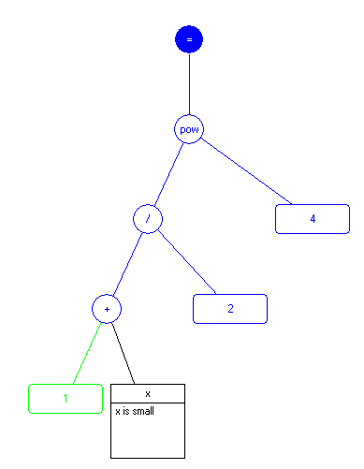
      2. NetWeaver has a rich set of math operators if needed
   3. Another option is a fuzzy node (see below)

# Fuzzy nodes and switches

1. A fuzzy node is an alternate way to build a fuzzy argument
2. Fuzzy nodes versus fuzzy arguments
   1. A fuzzy argument is hardwired into the model
   2. A fuzzy node can read its parameters from a database – generality
   3. The parameters of a fuzzy node may themselves be functions of other data inputs

|  |  |
| --- | --- |
|  |  |

# Switches

1. Switches can function as lookup tables as in the previous example
2. Switches can also be used to select among alternative logic pathways
   1. E.g., you can alter the logical flow based on contextual information

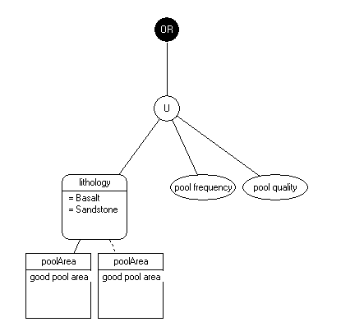

# Taking a tour of some logic models (knowledge bases)

1. Evaluation of stream reaches for salmon habitat (chewR)
2. Evaluation of watersheds for salmon habitat (chewWS)
3. Evaluation of wildfire potential (PNW firedanger 2012, NW_firedanger4.nw)

# Next lecture

1. We build some logic models
2. Hands on
3. Instructor led

# Reading

Reynolds, K.M., K.N. Johnson, and S.N. Gordon. 2003. The science/policy interface in logic‑based evaluation of forest ecosystem sustainability. Forest Policy and Economics 5:433-446.